Lesson plan: Countable and uncountable nouns - KIDS

Title: THE SHOPPING LIST

Language needed: grocery vocabulary

Approximate time: 60 minutes

Materials: worksheets, Quizlet, YouTube video, online game

Warm up: type of container

Quizlet: <https://quizlet.com/_62zs6m>

Exercise: worksheet A

Explain the difference between countable and uncountable using the sway with the grammar and the YouTube Video.

Song: https://www.youtube.com/watch?v=oWAC0Nd09Fg

Vocabulary: https://quizlet.com/_62zmj4

Online game: <https://elt.oup.com/student/horizonscee/games/frog2?cc=gr&selLanguage=en>

Write some of the new word in the worksheet B with your student.

You can cut pictures for a magazine and clue in the worksheet.

Bingo

Do a Bingo with Worksheet C and ask what is countable and uncountable.

Reading Comprehension: Worksheet D

Discussion

Do you like going to the supermarket?

What do you like buying in the supermarket?

Do you ever go shopping for food?

Who goes shopping for food in your house?

## **WORKSHEET A – WARM UP**

Write the name of the packages under the correct pictures you see below

a bag of…     a can of…     a bundle of…    a box of… a container of…    a spray can of…

a cup of… a carton of…    a sack of…     a tube of…     a jar of… a bottle of…

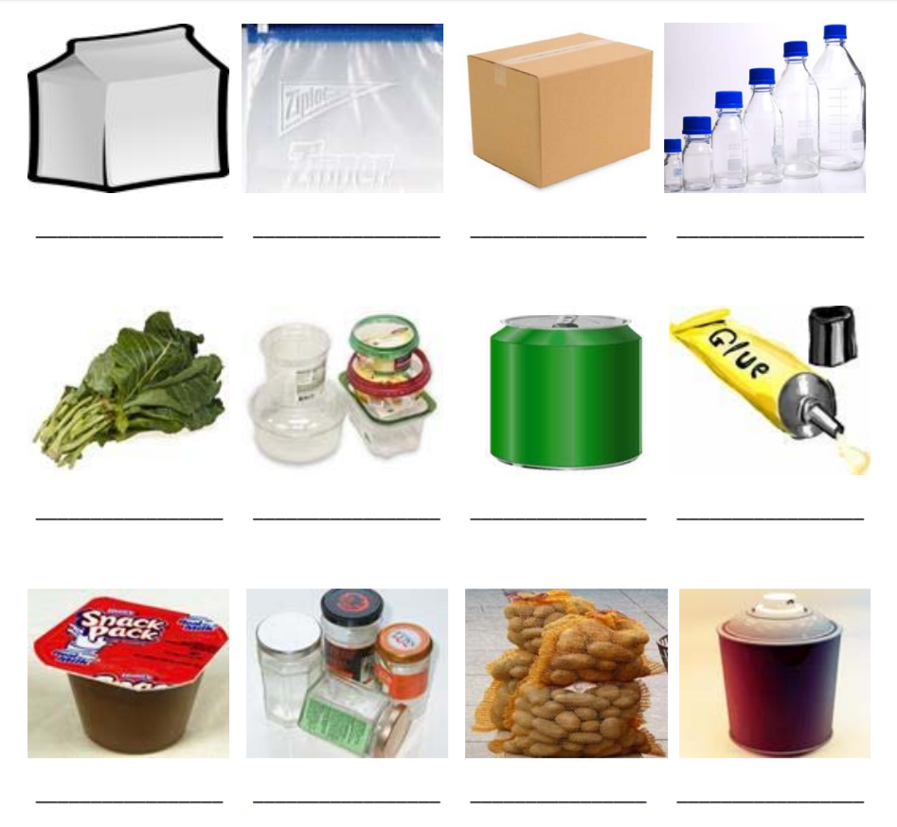

## **WORKSHEET B**

|  |  |  |
| --- | --- | --- |
| **Type of containers** | **Uncountable noun** | **countable** |
|  |  |  |

## **WORKSHEET C – BINGO**

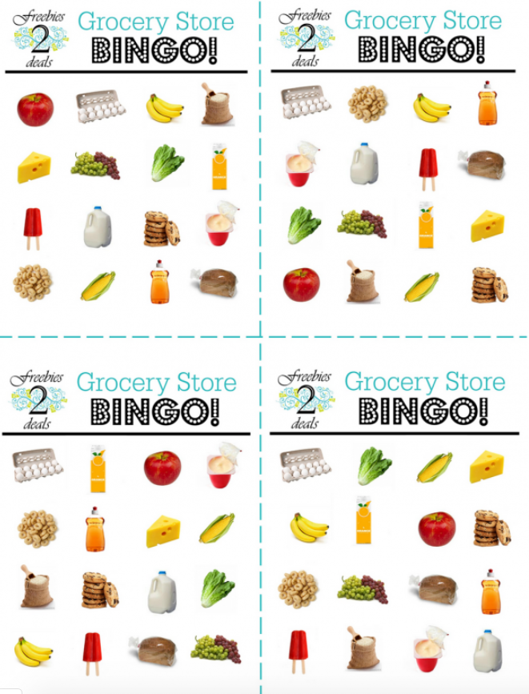

## **WORKSHEET D – Reading**

Read the following text and answer the questions.

Shopping at the Supermarket

I’m Sara and I am at the supermarket. I am with my daughter Claire. She loves supermarkets and I like them, too.

Let me see… I like apples and coke. Claire prefers grapes and orange juice. For breakfast I like milk and you, do you like milk?

Claire likes yoghurts of all kind. I also like vegetables: lettuce and carrots. We don’t like onions and lemons.

1. Where is Sarah?
2. Does Claire like supermarkets?
3. What does Sarah like?

_________________________________________________________________________________