Lesson plan: Countable and uncountable nouns.

Title: THE SHOPPING LIST

Language needed: count and non-count nouns containers (for food)

Approximate time: 60 minutes

Instruction: This lesson play was made to attend different levels of knowledge. Each teacher must select her own choice and which options she is going to use with that student.

Materials: worksheets, Quizlet, YouTube video, online exercises

Warm up: type of container

Quizlet: https://quizlet.com/_62zs6m

Exercise: worksheet A

Explain the difference between countable and uncountable using the sway with the grammar and the YouTube Video.

<https://www.youtube.com/watch?v=1SbJ1B1MTQg> (basic)

<https://www.youtube.com/watch?v=PMb56-uVYhk> (intermediate)

Work together as a class or as a pair. Look at the shopping list and the picture (Quizlet).

Quizlet: https://quizlet.com/_62zyki

Briefly explain how many types of food can be count or non-count, depending on whether another word is used in front of it.

* Look at more food words and write count or non-count
* Use the worksheet with the table to write new words – worksheet B
* Look at the words that can be used in front of the non-count nouns to make them

count (loaf, head, etc.)

* Online exercises: <https://agendaweb.org/grammar/countable_uncountable-exercises.html>
* In each pair, one student (or teacher) is the student A and one is the husband. Without looking at each other’s paper, they must write a number next to each food. For this part of the activity, you must use the containers so that you can count the items. – Worksheet C or google form
* Then the students switch papers and work with a different partner so that the roles are reversed with different information to compare.
* Conversation about supermarkets (also in Quizlet)
* Reading and listening comprehension

http://www.elllo.org/video/grammar/L2-04-Nat-Quantifiers.html (basic)

http://www.elllo.org/english/1401/1416-MegTodd-Chores-Laundry.htm (intermediate)

## **WORKSHEET A – WARM UP**

Write the name of the packages under the correct pictures you see below

a bag of…     a can of…     a bundle of…    a box of… a container of…    a spray can of…

a cup of… a carton of…    a sack of…     a tube of…     a jar of… a bottle of…

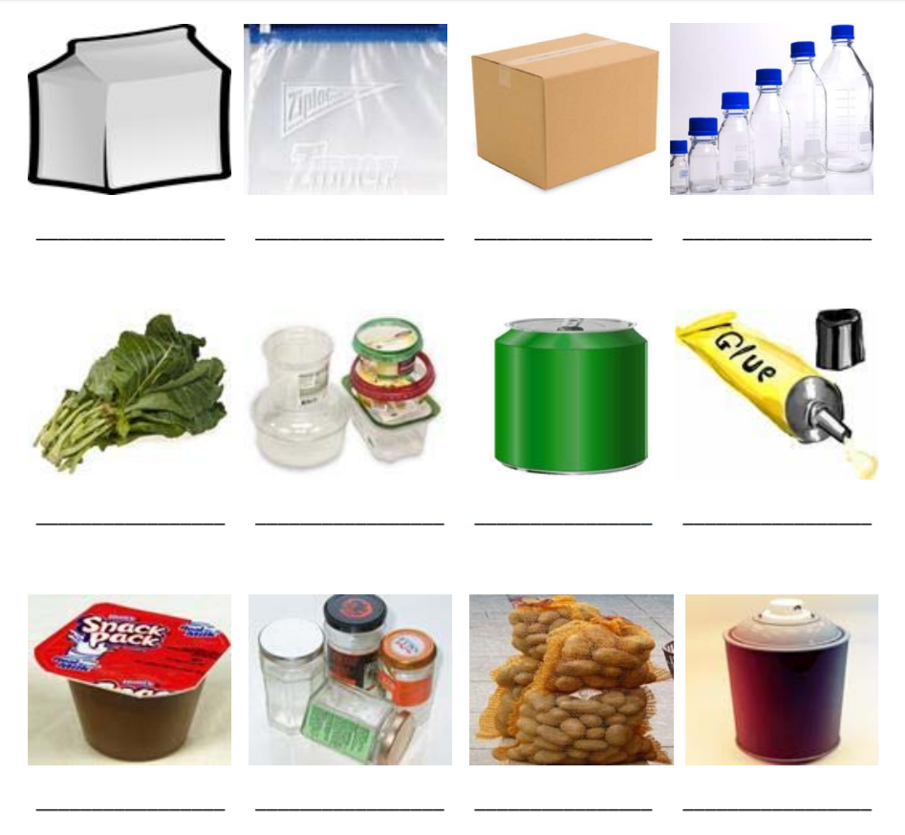

## **WORKSHEET B**

|  |  |  |
| --- | --- | --- |
| **Type of containers** | **Uncountable noun** | **countable** |
|  |  |  |

## **WORKSHEET C - STUDENT A**

Are these words COUNT or NON-COUNT?

Write C or N next to each word.

bread____

carrots____

flour____

sugar____

lemons____

muffins____

lettuce____

tomatoes____

onions____

apple juice

Write a number next to each type of food. This is what you need.

Bread: ___________loaf/ loaves of bread

Sugar: ___________bag/ bags of sugar

Lettuce: __________head/ heads of lettuce

Apple juice:_________bottle/ bottles of apple juice

Carrots:____________carrot/ carrots

Lemons: ___________lemon/ lemons

Tomatoes: ____________tomato/ tomatoes

Flour: _____________ bag/ bags of flour

Muffins:_____________muffin/ muffins

Onions: _____________onion/ onions

## **WORKSHEET D - STUDENT B**

Are these words COUNT or NON-COUNT?

Write C or N next to each word.

bread____

carrots____

flour____

sugar____

lemons____

muffins____

lettuce____

tomatoes____

onions____

apple juice _____

Write a number next to each type of food. This is what you bought.

Bread: ___________loaf/ loaves of bread

Sugar: ___________bag/ bags of sugar

Lettuce: __________head/ heads of lettuce

Apple juice:_________bottle/ bottles of apple juice

Carrots:____________carrot/ carrots

Lemons: ___________lemon/ lemons

Tomatoes: ____________tomato/ tomatoes

Flour: _____________ bag/ bags of flour

Muffins:_____________muffin/ muffins

Onions: _____________onion/ onions

Conversation about supermarkets

Quizlet: https://quizlet.com/_6302ju

Do you like to go to the supermarkets?

What do you usually shop for?

Where do you go shopping?

Are there many supermarkets in your neighborhood?

Do you spend much money on shopping at a supermarket?

Do you usually shop online? What items?

Name 5 items that you always buy in a supermarket?

Give 4 products that are packaged in plastic.

Give 4 products that are packaged in cardboard.

Give 4 products that are not packaged in anything.